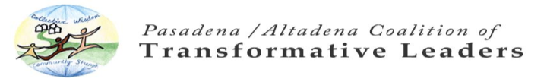

PACTL CORE VALUES/PRACTICES
PACTL’s organizational culture of core values/practices is the transformative engine at the heart of PACTL’s Theory of Change. These core values/practices are embedded in all aspects of PACTL’s work and are crucial to building the trust and goodwill PACTL has earned in the community, and why people are eager to volunteer. PACTL actively works to share these core values/practices with all who touch PACTL’s work – whether they are a parent program participant, professional service provider, or volunteers. 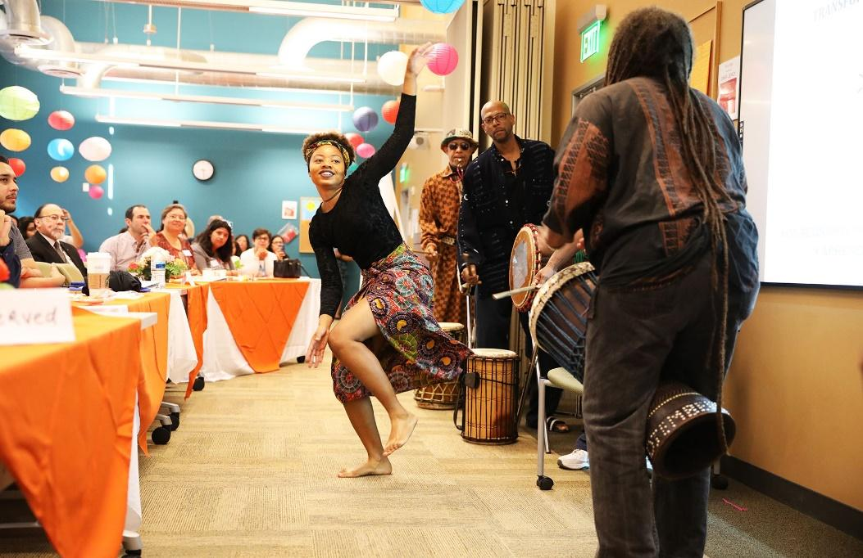
- CAPACITY STRENGTHENING – A core organizational value/practice of PACTL is strengthening the capacity of all who touch our work. PACTL works to strengthen the capacity of parents (and families) to support their children to succeed by learning skills in leadership, communication, civic engagement, parenting, nutrition, English, and advocacy. PACTL works to strengthen the capacity of professionals, organizations, agencies, and volunteers to collaborate to increase their effectiveness when serving the community.
  - What is the measurable effect of this? (RFE eValuations)
    - GS/K – Growth in Skills/Knowledge
    - CA/O – Change in Attitude/Opinion
    - CB – Change in behavior
    - CC – Change in Circumstances
  - What is the wider benefit of our work?
    - Contributing to a community of skilled parents
    - Contributing to a community of skilled communicators
    - Contributing to a community of skilled advocates
    - Contributing to a community of skilled collaborators
  - What is the long term change we see as our goal?
    - Parents prepared to support their children to succeed.
    - Professionals, organizations and agencies collaborate to increase their effectiveness when serving the community.
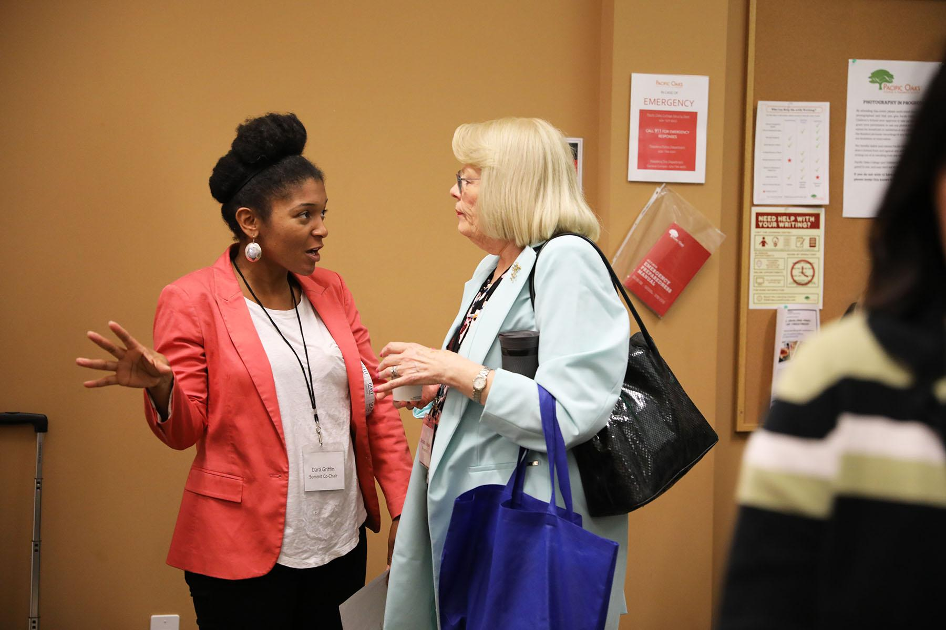
- INTER-GENERATIONAL APPROACH – PACTL believes that change does not occur in a vacuum. The entire family must support change in order for it to be sustainable. For children to succeed, they must be supported at home by parents, grandparents, and other siblings too.
  - What is the measurable effect of this?
    - Leveraging outcomes by maximizing care
    - Everyone in the family recognizes they play an important role in the success of the children.
    - Children learn from broad experience
  - What is the wider benefit of our work?
    - Increased family communication
    - Increased family quality time together
    - Increased grandparent engagement as an important role
  - What is the long term change we see as our goal?
    - Parents prepared to support their children to succeed

- APPRECIATIVE INQUIRY– PACTL emerged out of an Appreciative Inquiry workshop that participants wanted to go on forever. All of PACTL’s programs/activities honor and utilize Appreciative Inquiry – a model developed by David Cooperrider of Case Western Reserve University that seeks to engage stakeholders in the transformative process.
  - What is the measurable effect of this?
    - Our work is all strength/asset based
    - Our approach promotes respect among all stakeholders
    - Our work is led by our hopes and dreams and not our fears
  - What is the wider benefit of our work?
    - Others learn this effective approach
  - What is the long term change we see as our goal?
    - Others share this effective approach
    - Professionals, organizations, and agencies are collaborating to increase their effectiveness when serving the community.
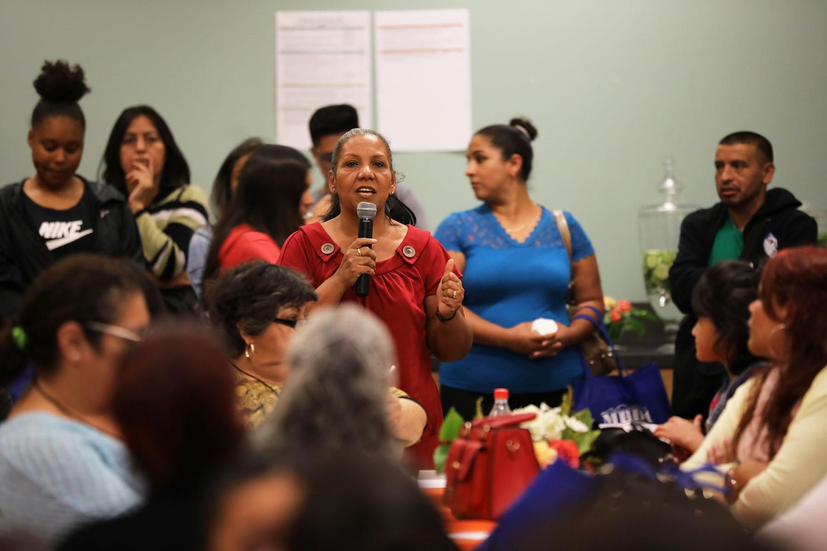
- MUTUAL ASSISTANCE - Our organizational culture honors Mutual Assistance or Reciprocity (participants take and give). PACTL transmits value by modelling a new, inclusive paradigm of parents and professionals working together, and through targeted Capacity Strengthening. Those who receive PACTL’s services also possesses valuable skills and abilities to share. Everyone who receives a benefit from PACTL learns the value of sharing their own contributions with others and learns the value of giving something back though volunteerism.
  - What is the measurable effect of this (not yet measured)?
    - Program participants (parents, grandparents and caregivers) feel like valued partners in change, and not like units of service receiving handouts or charity from the experts/professionals
    - Professionals are seen by parents as allies with the common goal of helping to prepare parents to support their children to succeed
    - Professionals recognize that parents are experts with regard to their circumstances and needs
  - What is the wider benefit of our work?
    - Parents and professionals work collaboratively toward helping prepare parents to support their children to succeed.
  - What is the long term change we see as our goal?
    - Parents are prepared to support their children to succeed
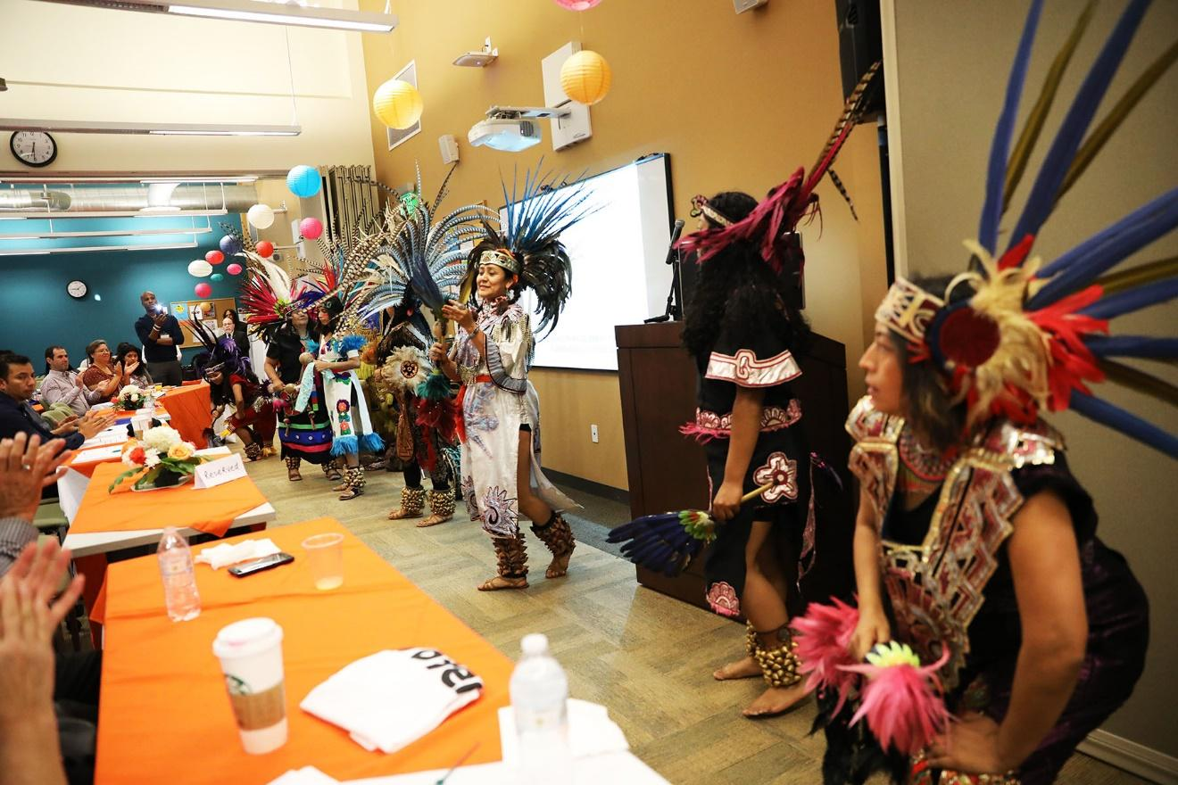

- COMMUNITY MEMBERS AS COMMUNITY EXPERTS: Parents, youth, grandparents, caregivers are invaluable experts regarding their own experience, their community, and their needs, and the best way to address barriers they may face to support their children to succeed. They possess innate gifts or skills which from their life, culture, background, that are of value and can be shared. They are honored by PACTL through building their capacity to support their children to succeed
  - What is the measurable effect of this?
    - Relevant needs assessment
    - Invaluable for baseline data for evaluation efforts
    - Necessary change partners for sustainability
    - They know their own challenges best
    - They know their own skills best
    - They possess valuable insights into the community served by PACTL.
  - What is the wider benefit of our work?
    - Inform the field
    - Parents and professionals work collaboratively to help prepare parents to support their children to succeed.
  - What is the long term change we see as our goal?
    - Parents are prepared to support their children to succeed.
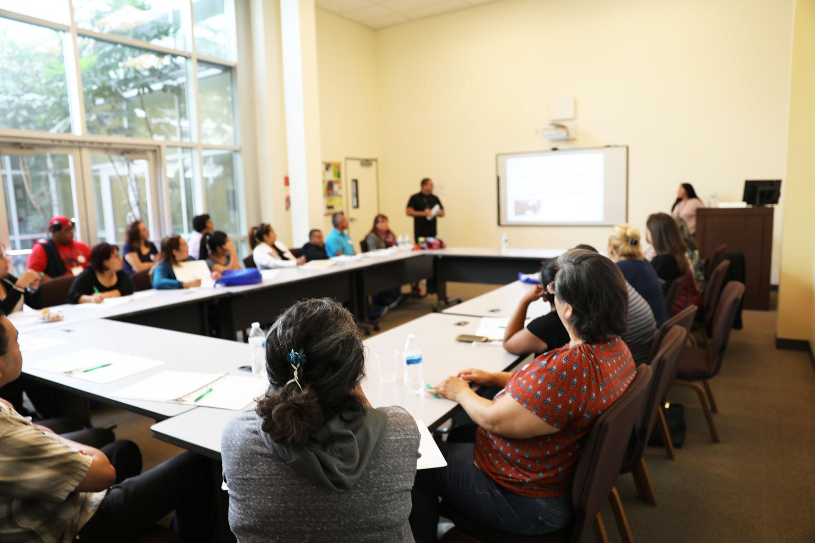

- PROFESSIONAL/PARA-PROFESSIONAL PARTNERSHIPS – Professionals and academics are important to help prepare parents to support their children to succeed. Many communities have been exploited and/or abandoned by professionals who don’t take adequate time to build trust, and leave without conferring any benefit to studied communities. Professionals and academics sometimes feel they have all the answers and therefore are unable to listen. There is often deep mistrust toward professionals within communities. Professionals who work with PACTL have their own capacity strengthened and experience a new paradigm of working with communities where they are honored as welcome partners in change who possess unique insights and skills to contribute.
  - What is the measurable effect of this?
    - Re-defined working relationship where both are co-authors of the desired change, or, co-presenters if presenting a workshop together (e.g. Biennial Summit),
    - Growth in partnership, leadership, and communication skills
    - Para-professional is recognized and valued as an important contributor
  - What is the wider benefit of our work?
    - Participants experience, learn and share a new paradigm in effective professional/para-professional partnerships
  - What is the long term change we see as our goal?
    - Local organizations and agencies collaboration increase their effectiveness when serving the community
    - Parents are prepared to support their children to succeed
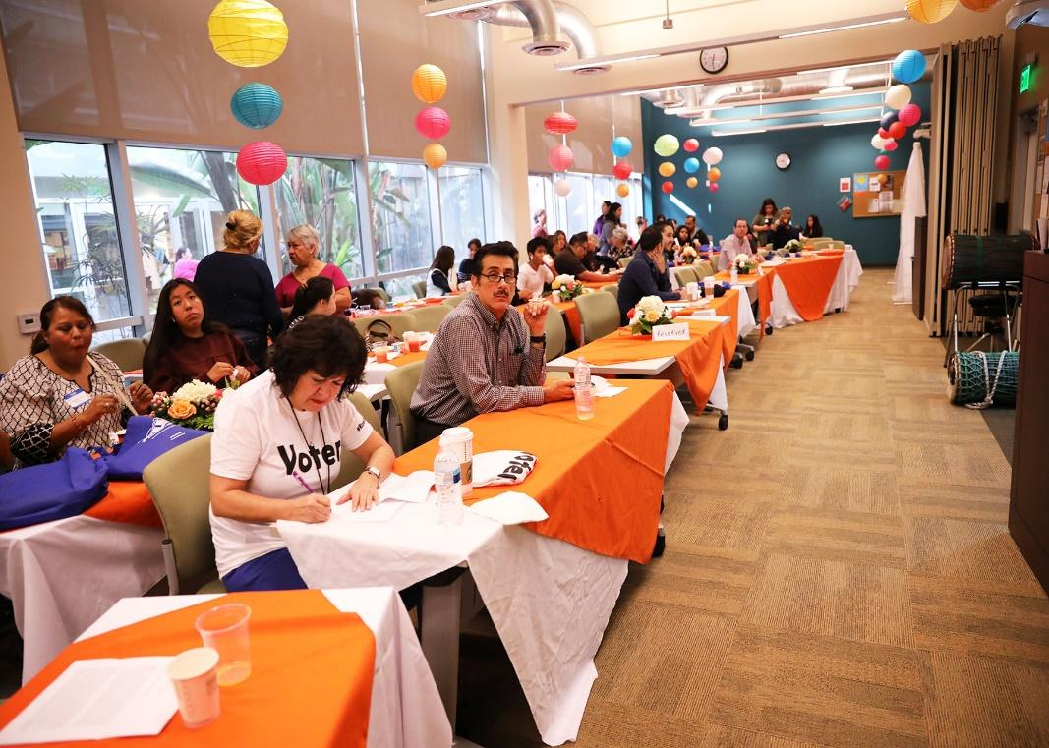

- MEANINGFUL COMMUNITY ENGAGEMENT - PACTL recognizes that building community trust and goodwill takes time, commitment, and skill, and that the process easily falls prey to miscommunication, perceived untruth(s), cutting off community supports, etc.
  - What is the measurable effect of this?
    - Buy-in and ownership by parents, grandparents, caregivers, youth, and community
    - Open communication
    - Trust relationships
  - What is the wider benefit of our work?
    - Community becomes more open to engagement
    - Professionals become more skilled in creating meaningful community engagement
  - What is the long term change we see as our goal?
    - Parents are prepared to support their children to succeed.
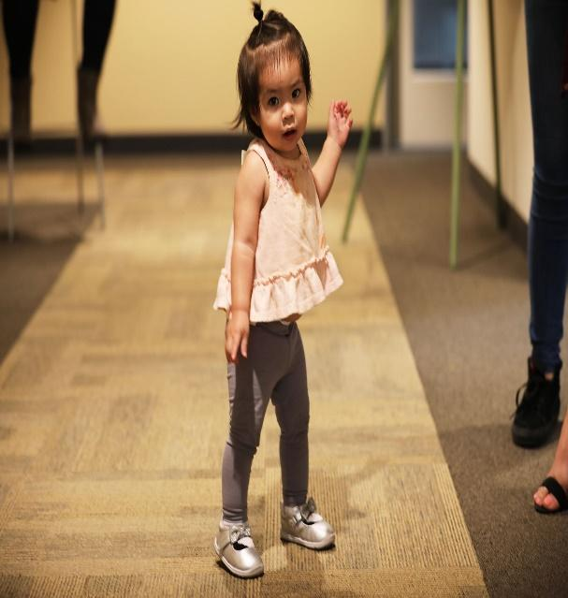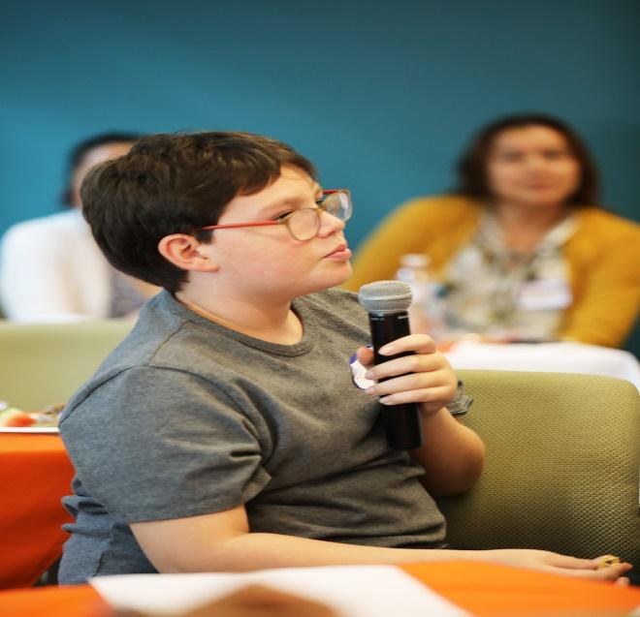

- OUR ORGANIZATIONAL MEETING “NORMS”
  - What is the measurable effect of this? Organizational harmony, open communication
  - What is the wider benefit of our work? Modelling
  - What is the long term change we see as our goal? Other orgs/agencies adopt Norms.

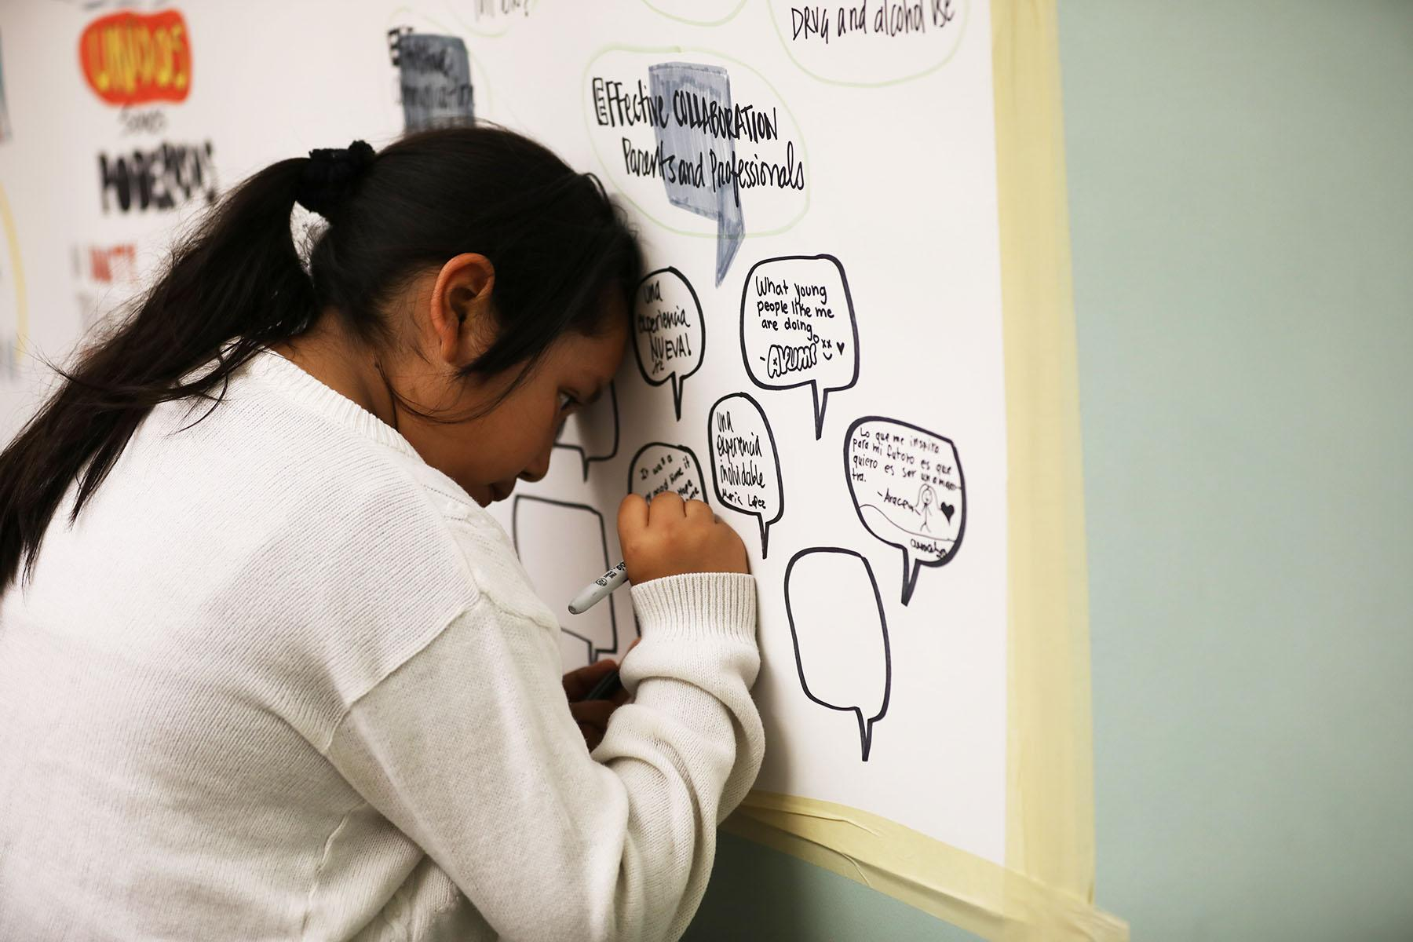

- LEARNING COMMUNITY – PACTL’s organizational culture is that of a learning community where knowledge is collected and shared through programs/activities, materials, trainings, workshops, and our Lending Library including works on health, leadership, law, advocacy, etc.
  - What is the measurable effect of this? GS/K
  - What is the wider benefit of our work? Modelling
  - What is the long term change we see as our goal? Organizations and Agencies becoming learning communities.

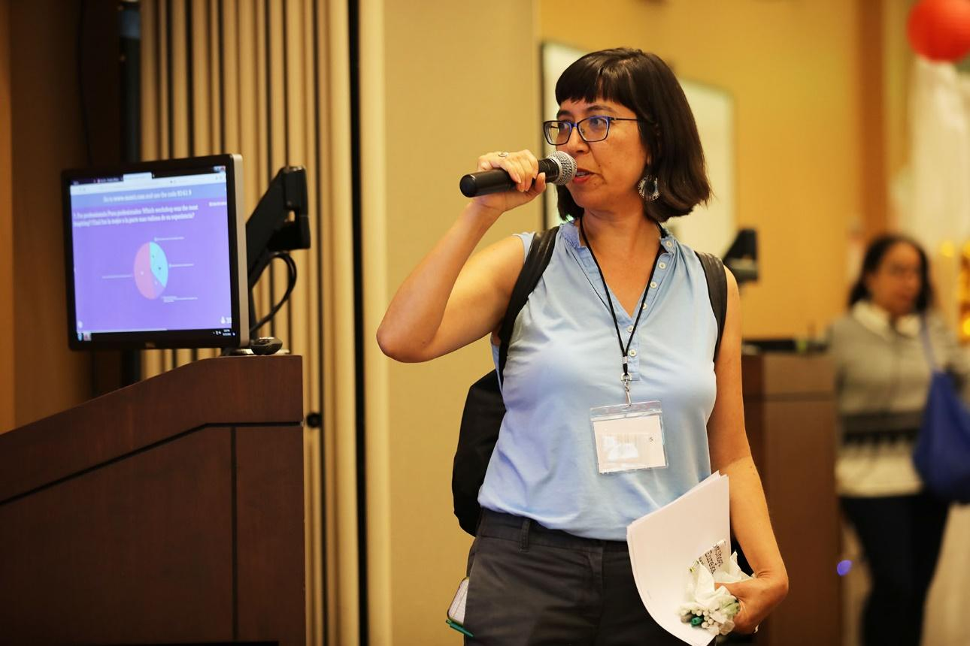

- EVALUATION - Feedback loops are embedded in all aspects of PACTL’s work and the organization itself through the Parent/Youth Networks, which serve as advisory bodies and select organizational priorities, Results Based Accountability (RBA), SOAR analysis (AI), Evidence Based Practices, and eValuation of our programs and events.
  - What is the measurable effect of this? Self-assessment
  - What is the wider benefit of our work? Improve programs and delivery
  - What is the long term change we see as our goal? Improve programmatic outcomes.

